**Industry Data**

**Having looked at the Burning Glass data, has your opinion of your ideal job changed? Why or why not?**

**Quantum researcher:**

No, my desire to become a quantum researcher has increased after analysing CSIRO’s “Growing Australia’s Quantum Technology Industry” 2020 report. Quantum technologies are going to create incredible research opportunities throughout the world. Businesses in Australia are set to generate over $4 billion and create 16,000 jobs by 2040. Our Quantum Computing industry is predicted to be worth $2.5B and produce 10K jobs.

Quantum research opportunities range in industries from large technology companies such as Google, IBM and Microsoft, to defence, mining and medicine.

, to drug discovery and development. accelerated drug and materials development enabled by accurate chemical simulations that run on quantum computers and draw on computation capability not possible on classical computers • stable and precise sensors for mineral exploration and water resource management • quantum-enhanced information security for sensitive data and critical infrastructure

Many governments are implementing strategic investment programs to develop their domestic quantum industries. Since 2017, at least 5 nations have committed to billion-dollar scale quantum technology initiatives or funding packages (see Table 1). China is also investing heavily, including a reported $14.7 billion for the world’s largest quantum research facility.8

While the Burning Glass data places Java code knowledge as more in demand than Python, my particular field of interest requires a through understanding of Python.

Established R&D capabilities

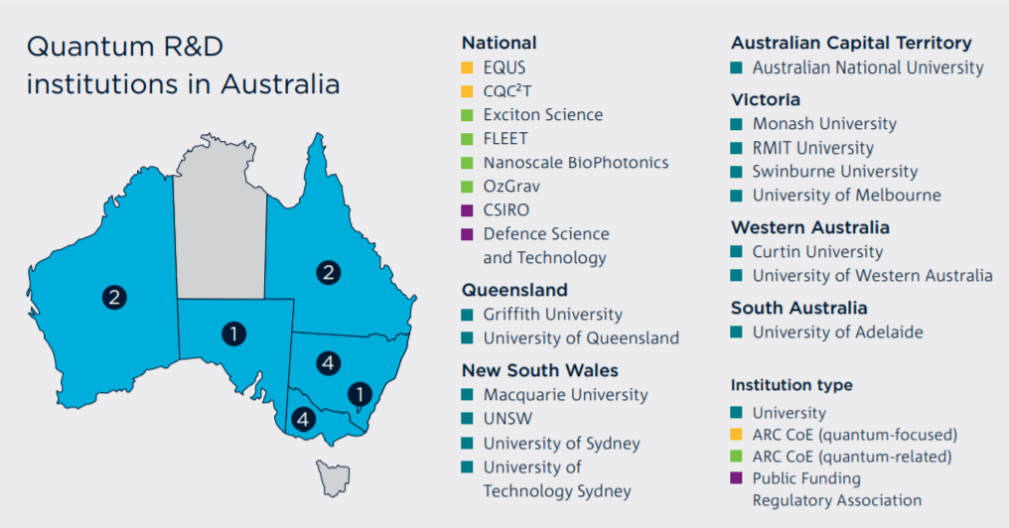 Figure 2. Australian research institutions active in quantum technologies11

11 See Appendix B. Tables 2 and 3 for detailed lists of Australian research institutions active in quantum technologies. ‘Well above world standard’ is a rating defined by the Australian Research Council against its set of evaluation indicators. https://dataportal.arc.gov.au/ERA/NationalReport/2018/pages/ introduction/index.html?id=era-2018-evaluation-process

CSIRO recommends Enhance research and training linkages between Australian Universities with complementary quantum strengths. RMIT currently does not have a quantum computer, however does participate in the ARC Centre of Excellence for Quantum Computation and Communication Technology research alliance. This University of NSW does.

The data clearly shows there is a great demand for people with skills in coding, algorithms, quantum computers